DESIGN & DEVELOPMENT OF

HOSTEL RESERVATION SYSTEM

A

**MINOR PROJECT-II REPORT**

Submitted in partial fulfilment of the requirements for

the degree of

**BACHELOR OF TECHNOLOGY**

in

**COMPUTER SCIENCE & ENGINEERING**

by

**GROUP NO.17**

NEERAJ KUMAR 0187CS201106

MOHIT GAUTAM 0187CS201095

MD REHAN 0187CS201087

KAPIL BARSKER 0187CS201073

Under the guidance of

**Mr. Amit Kumar Rathore**

(Assistant professor)



**June -2023**

**Department of COMPUTER SCIENCE & ENGINEERING Sagar**

**Institute of Science &Technology (SISTec)**

**Bhopal (M.P.)**

**AnISO9001:2008 Certified Institution Approved by AICTE, New Delhi & Govt.ofM.P. Affiliated to Rajiv Gandhi Proudyogiki Vishwavidyalaya, Bhopal(M.P.)**

Sagar Institute of Science & Technology (SISTec), Bhopal

Department of COMPUTER SCIENCE & ENGINEERING

Bhopal (M.P.)



***June -2023***

**CERTIFICATE**

We here by certify that the work which is being presented in the B.tech. Minor Project-II Report entitled **Design & Development of Hostel Reservation System**, in partial fulfillment of the requirements for the award of the degree of **Bachelor of Technology in Computer Science & Engineering** and submitted to the Department of Computer Science & Engineering, Segar Institute of Science & Technology (SISTec), Bhopal (M.P.) is an authentic record of our own work carried out during the period from Jan-2023 to June- 2023 under the supervision of **Prof. Amit Kumar Rathore** **(Assistant Professor).** The content presented in this project has not been submitted by our for the award of any other degree elsewhere.

**Signature**

NEERAJ KUMAR 0187CS201106

MOHIT GAUTAM 0187CS201095

MD REHAN 0187CS201087

KAPIL BARSKER 0187CS201073

This is to certify that the above statement made by the candidate is correct to the best of our knowledge.

**Date:**

|  |  |  |
| --- | --- | --- |
| **Prof. Amit Kumar Rathore** | **Mr.Rahul Dubey** | **Dr.Keshavendra Choudhary** |
| **Project Guide** | **HOD** | **Principal** |

**ABSTRACT**

An online hostel reservation system is a web-based platform that enables users to book accommodation at hostels from any location, at any time, using the internet. The system provides a user-friendly interface that allows users to search for hostels by location, price, amenities, and availability, among other criteria. Once a user finds a suitable hostel, they can book a room, make a payment, and receive a confirmation of their reservation. The system also enables hostel owners to manage their inventory, update room availability, and view booking details. This paper discusses the design and implementation of an online hostel reservation system, including its architecture, features, and functionality. The benefits of using such a system include improved efficiency, increased accessibility, and enhanced customer satisfaction.

**ACKNOWLEGMENT**

It gives us immense pleasure to express our deepest sense of gratitude and sincere thanks to our highly respected and esteemed guide **Prof. Amit Kumar Rathore** and our Project Coordinator **Prof. Ruchi Jain**, Department of Computer Science and Engineering , SISTec Gandhi Nagar Bhopal, for their valuable guidance, encouragement and help for completing this work. Their useful suggestions for this whole work and cooperative behavior are sincerely acknowledged.

We would like to express our sincere thanks to **Dr. Swati Saxena**, Vice Principal, SISTec,Gandhi Nagar, Bhopal for giving us an opportunity to under take this project.

We also wish to express our gratitude to **Prof.Rahul Dubey**, Head, Department of Computer Science and Engineering,for his kind-hearted support.

At the end,we would like to express our sincere thanks to all our friends and others who helped us directly or indirectly during this project work.

**Name**  **Enrollment Number** **Signature**

|  |  |  |
| --- | --- | --- |
| NEERAJ KUMAR |  | 0187CS201106 …………….. |
| MOHIT GAUTAM |  | 0187CS201095 …………….. |
| MD REHAN |  | 0187CS201087 …………….. |
| KAPIL BARSKER |  | 0187CS201073 …………….. |

**LIST OF FIGURES**

|  |  |  |
| --- | --- | --- |
| **FIG. NO.** | **TITLE** | **PAGE NO.** |
| 5.1 | USE CASE DIAGRAM | 16 |
| 5.4 | CLASS DIAGRAM | 20 |
| 6.2 | ER DIAGRAM | 23 |

**LIST OF ABBREVIATIONS**

|  |  |
| --- | --- |
| **ACRONYM** | **FULLFORM** |
| SDLC | Software Development Life Cycle |
| SQL | Structured Query Language |
| HTML | Hyper Text Markup Language |
| CSS | Cascading Style Sheets |

**TABLE OF CONTENTS**

|  |  |  |  |  |
| --- | --- | --- | --- | --- |
| **TITLE** | | **PAGE NO.** | | |
| Abstract | | iii | | |
| Acknowledgement | | iv | | |
| List of figures | | v | | |
| List of abbreviations | | vi | | |
| Chapter 1 | Introduction   * 1. About Project   2. Project Objectives   3. Functionality   4. Interface   5. Design and Implementation Constraints   6. Assumptions and Dependencies | 3  4  4  5  5  5  6 | | |
| Chapter 2 | Software & Hardware Requirements 8  2.1 Introduc  2.2 Software Requirements 9  2.3 Hardware Requirement 10 | | |  |
| Chapter 3 | Problem Description 11  3.1 Overview 12 | |  |
| Chapter 4 | Literature Survey 14 | |  | |
| Chapter 5 | Software Requirements Specification 15  5.1 Use Case Diagram 16  5.2 Functional Requirement 17  5.3 Non Functional Requirement 18  5.4 Class Diagram 20 | |  | |
| Chapter 6 | Software Design 21  6.1 Schema Diagram 22  6.2 ER Diagram 23 | |  | |
|  |  |  | | |

Chapter 7 Interface Screenshots 24

7.1 Output Screen Of Hostel Reservation 25

Chapter 8 Deployment 36

8.1 Introduction 37

8.2 Download Vs code 37

8.3 Run the Setup Program and Follows the prompts 38

8.4 Change the Run/Debug Configuration 41

8.5 Change the Build Variants 42

8.6 Installation of SQlite 43

Chapter 9 Conclusion & Future Work 48

9.1 Conclusion 49

9.2 Future Work 49

References 50

Appendix-1: Glossary of Terms 51

Project Summary 53-57



# 

# **CHAPTER-1 INTRODUCTION**

* 1. **ABOUT PROJECT**

A hostel reservation system is a software application that enables customers to book and manage

their reservations at a hostel online. It can be used by both customers and hostel managers to streamline the booking process and ensure that all reservations are managed effectively.Some common features of a hostel reservation system include:

**1.** **Online booking:** Customers can browse available rooms, select dates and make reservations online.

**2.** **Room inventory management**: Hostel managers can keep track of available rooms, their capacity, pricing and availability for specific dates.

**3.** **Payment processing:** Hostel reservation systems can integrate with payment gateways to securely process customer payments.

**4.** **Reservation management:** Hostel managers can view, modify, or cancel reservations as needed.

**5. User accounts:** Customers can create accounts and manage their reservations, payment history and other information.

**6**. **Email and SMS notifications:** Customers can receive confirmation of their bookings via email or SMS.

**7.** **Reporting and analytics:** Hostel managers can generate reports and track data related to reservations, occupancy rates, and revenue.

When building a hostel reservation system, it's important to consider factors such as security, scalability, and user experience. The system should be designed to handle high traffic loads and ensure that customer data is kept secure. A well-designed user interface can improve the user experience and encourage customers to return to the hostel in the future.

* 1. **PROJECT OBJECTIVES**

The main objective of a hostel reservation system is to provide a convenient and efficient way for customers to book and manage their reservations at a hostel. By using a hostel reservation system, customers can easily browse available rooms, select dates, and make reservations online, without the need to visit or call the hostel directly. For hostel managers, the system helps streamline the booking process, making it easier to manage inventory track reservations, and process payments. By automating many of these tasks, hostel managers can free up time to focus on other important aspects of running their business. In addition to improving the booking process, a hostel reservation system can also help increase revenue by providing greater visibility into occupancy rates and allowing for dynamic pricing based on demand.

Overall, the objective of a hostel reservation system is to create a win-win situation for both customers and hostel managers by making the booking process simpler, more efficient, and more profitable for everyone involved.

**1.3 FUNCTIONALITY**



Without login Student can visit this website.



Student can check room availability.

 Then Student login this website and Booking.

**1.4 INTERFACE**

This application interacts with the users through web pages. The interface is simple easy to handle and self-explanatory opened ,user will easily come in to the flow with the website and easily uses all interfaces properly.

**1.5 DESIGN AND IMPLEMENTATION CONSTRAINTS**



**Technical Constraints:**

1. **Platform:** The system needs to be compatible with the hardware and software platforms that will be used by the hostel staff and customers.
2. **Scalability:** The system should be able to handle a large number of users simultaneously, without crashing or slowing down.
3. **Security:** The system must be secure and protect the data of the users from any unauthorized access or hacking.
4. **Integration:** The system should be able to integrate with other systems used by the hostel such as payment gateway and accounting software.



**Operational Constraints:**

* 1. **User-Friendly:** The system should be user-friendly and easy to use for both hostel staff and

customers.

* 1. **Accessibility:** The system must be accessible to all users, including those with disabilities.
  2. **Performance:** The system should perform well and be responsive, especially during peak

booking periods.

* 1. **Availability:** The system should be available 24/7 to enable users to make bookings at any

time.



**Regulatory Constraints:**

1. **Compliance:** The system must comply with all relevant data protection and privacy regulations.
2. **Payment Regulations:** The system should comply with all relevant payment regulations

and requirements.

1. **Localization:** The system should comply with local language and cultural norms.
2. **Accessibility:** The system should comply with all accessibility regulations, such as the Americans with Disabilities Act (ADA) in the United States.

**1.6 ASSUMPTIONS AND DEPENDENCIES**

* **Assumptions:**

1. **Availability of necessary resources:** It is assumed that the hostel reservation system will have access to necessary resources such as hardware, software, and internet connectivity.
2. **Adequate staff training:** It is assumed that hostel staff will be adequately trained on how to use the system to make bookings, manage reservations, and generate reports.
3. **Customer competence:** It is assumed that customers will have basic computer skills to use the system to make bookings and payments.
4. **Reliable internet connectivity:** It is assumed that customers will have reliable internet connectivity to access the reservation system.
5. **Accurate data entry**: It is assumed that the data entered into the system by hostel staff and customers will be accurate and up-to-date.

* **Dependencies:**

1. **Integration with payment gateway:** The reservation system will be dependent on the payment gateway used by the hostel to accept online payments.
2. **Availability of inventory:** The reservation system will be dependent on the availability of inventory, such as the number of rooms and beds, to make reservations.
3. **Data protection regulations:** The reservation system will be dependent on data protection regulations to ensure that customer data is protected and handled appropriately.
4. **Internet connectivity:** The reservation system will be dependent on internet connectivity to enable customers to access the system and make bookings.



**CHAPTER-2**

**SOFTWARE & HARDWARE REQUIREMENTS**

**2.1 INTRODUCTION**

The software and hardware components of a computer system those are required to install and use application efficiently. The application manufacturer will list the system requirements on the package. If your computer system does not meet the system requirements then the application may not work correctly after installation. System requirement for operating system will be hardware components, while other application software will list both hardware and operating system requirements and Brower. System requirements are most commonly seen listed as minimum and recommended requirements. The minimum system requirements need to be met for the web application to run at all on your system, & the recommended system requirements, if met, will offer better software usability.

# **2.2 SOFTWARE REQUIREMENTS**

There are following software requirements to work on this project-Language: HTML,CSS,

JAVASCRIPT, DJANGO, MYSQL.

* Operating System: Windows
* Tool: Visual Studio Code

**HTML:**



HTML stands for Hyper Text Markup Language.

HTML is the standard markup language for creating Web pages.

HTML describes the structure of a Web page.

HTML elements label pieces of content such as "this is a heading", "this is a paragraph",

"this is a link", etc.

**CSS:**



CSS stands for Cascading Style Sheets.

CSS describes how HTML elements are to be displayed on screen, paper,or in other media

 CSS saves a lot of work. It can control the layout of multiple web pages all at once.

**JavaScript:**



JavaScript is the Programming Language for the Web.



JavaScript can update and change both HTML and CSS.

JavaScript can calculate, manipulate and validate data.

**DJANGO:**

 Excellent documentation and high scalability.

Used by Top MNCs and Companies, such as Instagram, Disqus, Spotify, Youtube, Bitbucket, Dropbox, etc. and the list is never-ending.

Easiest Framework to learn, rapid development and Batteries fully included.

The last but not least reason to learn Django is [Python](https://www.geeksforgeeks.org/python-programming-language/), Python has huge library and features such as Web Scraping, Machine Learning, Image Processing, Scientific Computing, etc. One can integrate it all this with web application and do lots and lots of advance stuff.

**SQULITE:**

• SQLite is a free and open-source software library.

• It supports standard SQL syntax and is compatible with many programming languages.

• SQLite databases are stored in a single file, making them easy to transport and backup.

• It has a small footprint and low overhead, making it ideal for use in resource-constrained

environments.

• SQLite is designed to be reliable, efficient, and scalable.

• It supports a wide range of data types, including text, numeric, date and time, and binary data.

• It provides built-in support for transactions, indexing, and triggers.

• SQLite is widely used in embedded systems, mobile devices, and desktop applications, as well as

in web and server applications.

# **2.3 HARDWARE REQUIREMENTS**



Processor: Dual-core 64-bit processor.

Ram: 256 Mb

Hard Disk: 8GB.



# 

**CHAPTER-3**

# **PROBLEM DESCRIPTION**

## **3.1 OVERVIEW**

The hostel reservation system is a software solution that helps manage the booking process for a hostel. The system should allow guests to search for available rooms, make reservations, and manage their bookings. The system should also allow the hostel staff to manage the inventory of rooms, view reservations, and process payments.

**The system should include the following features:**

**Room availability:** The system should allow guests to search for available rooms based on their preferred dates, room type, and occupancy.

**Room booking:** Once the guest selects the desired room, the system should allow them to make a reservation by providing their personal information, payment details, and any special requests.

**Reservation management:** The system should allow the hostel staff to manage reservations, including checking in guests, modifying reservations, and canceling bookings.

**Payment processing:** The system should integrate with payment gateways to process payments securely and in real-time.

**Room inventory management:** The system should allow the hostel staff to manage the inventory of rooms, including adding new rooms, updating room details, and removing rooms from the system.

**Reporting:** The system should provide comprehensive reports on occupancy, revenue, and other key performance indicators to help the hostel management make informed decisions.

**User management:** The system should allow the hostel staff to manage user accounts, including creating new accounts, modifying existing accounts, and disabling accounts.

**Security:** The system should ensure the security of all sensitive information, such as guest personal and payment details, by implementing appropriate security measures such as encryption and access controls.

Overall, the hostel reservation system should be user-friendly, easy to use, and reliable, to ensure a smooth booking process for guests and efficient management for hostel staff.



**CHAPTER-4**

# **LITERATURE SURVEY**

# A literature survey of hostel reservation systems would involve reviewing and analyzing the existing literature and research studies related to the topic. Here are some possible sources and areas to consider when conducting a literature survey on this topic:

**1.** **Academic research articles**: Search academic databases such as Google Scholar or IEEE Xplore for research studies on hostel reservation systems. Look for studies that explore the effectiveness of different reservation algorithms, user interfaces, and payment systems.

**2.** **Conference proceedings**: Review proceedings from conferences on hospitality and tourism, such as the International Conference on Hospitality and Tourism Management, to identify research studies and presentations related to hostel reservation systems.

**3**. **Industry reports:** Look for industry reports on the hospitality and tourism sector, including reports from market research firms such as IBISWorld and Euromonitor. These reports may provide insights into the latest trends and technologies in hostel reservation systems.

**4.** **Online resources:** Visit online forums, blogs, and social media groups related to hospitality and tourism to gain insights from practitioners and users of hostel reservation systems. Look for reviews and testimonials from hostel owners, managers, and guests to identify the strengths and weaknesses of different reservation systems.

**Some potential areas to explore in a literature survey of hostel reservation systems include:**

• Types of hostel reservation systems (e.g., web-based, mobile-based, automated)

• User interfaces and user experience design in hostel reservation systems

• Reservation algorithms and optimization techniques

• Payment systems and security in hostel reservation systems

• Integration of hostel reservation systems with other hospitality systems (e.g., property management systems, customer relationship management systems)

• Social and environmental impacts of hostel reservation systems

• Best practices and success factors for implementing and managing hostel reservation systems.

By conducting a literature survey of hostel reservation systems, researchers and practitioners can gain a deeper understanding of the current state of the art in this field and identify opportunities for future research and innovation.



**CHAPTER-5**

**SOFTWARE REQUIREMENTS SPECIFICATION**

**5.1 USE CASE DIAGRAM**

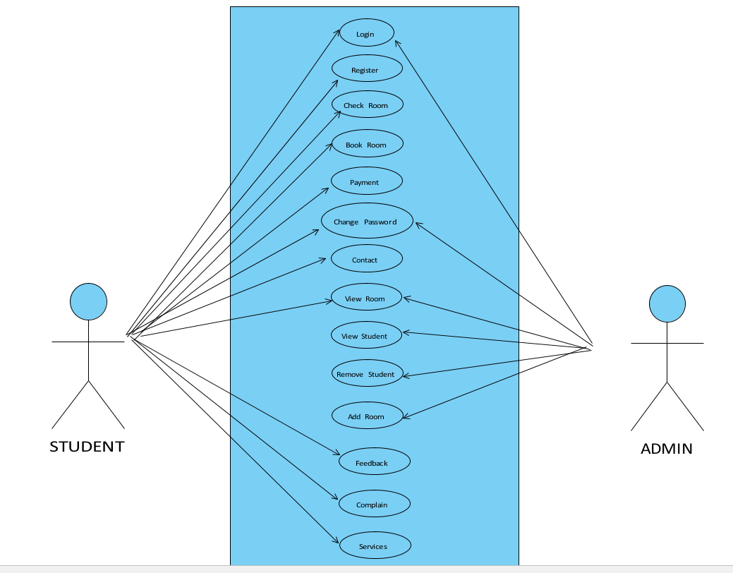

A use case diagram is a type of diagram in Unified Modeling Language (UML) that illustrates how different actors interact with a system to accomplish specific tasks or goals. In the context of a hostel reservation system, a use case diagram would show the different actors who interact with the system and the tasks they can perform. Here are some common actors and use cases in a hostel reservation system:

A Software requirement specification (SRS) is an in-depth document that describes what the software does and how we expect it to perform. An SRS includes information about all the functional and nonfunctional requirements for a given piece of software. The SRS serves as the main point of reference for the software development team who will build the software product, as well as for all other involved stakeholders.

**5.2 FUNCTIONALREQUIREMENTS**

There are two Actors in this project :

Admin

Student

**ADMIN CLASS**

1. **Inventory management:** The admin should be able to manage the inventory of available rooms, including adding or removing rooms, updating room details, and setting room rates.
2. **Student account management:** The admin should be able to manage student accounts, including creating or deleting accounts, updating personal information, and viewing booking history.
3. **Reservation approval/rejection:** The admin should be able to approve or reject student reservations, based on availability, payment status, or other criteria.
4. **Reservation modification/cancellation:** The admin should be able to modify or cancel reservations, based on the request of the student or due to operational reasons.
5. **Payment management**: The admin should be able to manage payment transactions, including issuing refunds, tracking payment status, and resolving payment disputes.
6. **Reporting and analytics:** The admin should be able to generate reports and analytics on occupancy, revenue, payment history, and other key performance indicators
7. **Communication and notifications**: The admin should be able to communicate with students via email, chat, or phone, and send notifications about reservation status, payment status, or other updates.
8. **User management:** The admin should be able to manage user roles and permissions, such as adding or removing users, updating access levels, and setting password policies.
9. **System configuration:** The admin should be able to configure system settings, such as timezone, language, payment gateway, and other system parameters.

**STUDENT CLASS**

**Functional requirements of a hostel reservation system for students may include:**

1. **Room search:** Students should be able to search for available rooms based on various criteria such as room type, occupancy, price, and dates.
2. **Room details:** Students should be able to view details about each room, including photos, amenities, and room layout.
3. **Reservation creation:** Students should be able to create a reservation for a specific room, with the option to select additional services such as meals, laundry, or transportation.
4. **Reservation modification:** Students should be able to modify their reservation, such as changing the dates or room type, as long as there are available rooms.
5. **Reservation cancellation:** Students should be able to cancel their reservation, with the option to receive a full or partial refund, depending on the cancellation policy.
6. **Payment:** Students should be able to pay for their reservation using various payment methods, such as credit card, PayPal, or bank transfer.
7. **Booking history:** Students should be able to view their booking history, including past reservations, cancellations, and refunds
8. **Notifications:** Students should receive notifications about their reservation status, payment confirmation, or any changes or updates related to their reservation.
9. **Feedback and reviews:** Students should be able to provide feedback and reviews about their experience, such as room quality, cleanliness, staff friendliness, and overall satisfaction.

* 1. **NON FUNCTIONAL REQUIREMENTS**

Non-functional requirements of a hostel reservation system are those requirements that describe the characteristics and qualities of the system, rather than its functionality. Here are some examples of non-functional requirements for a hostel reservation system:

1. **Performance:** The system must be able to handle a large number of simultaneous users and transactions without slowing down or crashing.
2. **Security:** The system must be secure and protect user data and transactions from unauthorized access, hacking, or theft.
3. **Usability:** The system should be user-friendly and easy to use, with a clear and intuitive user interface.
4. **Reliability:** The system should be reliable and available 24/7, with minimal downtime for

maintenance or upgrades.

1. **Scalability:** The system should be able to scale up or down to meet changing demand, without

sacrificing performance or usability.

1. **Compatibility:** The system should be compatible with different platforms, devices, and web

browsers, to ensure that users can access it from any device.

1. **Accessibility:** The system should be accessible to users with disabilities, with features like

keyboard navigation, screen readers, and high contrast settings.

1. **Maintainability:** The system should be easy to maintain and update, with clear documentation,

modular code, and a well-designed architecture.

1. **Interoperability:** The system should be able to integrate with other systems or APIs, such as

payment gateways or external booking engines.

These non-functional requirements are critical to the success of a hostel reservation system, as they ensure that the system is not only functional but also reliable, secure, usable, and accessible to all users.

* 1. **CLASS DIAGRAM**

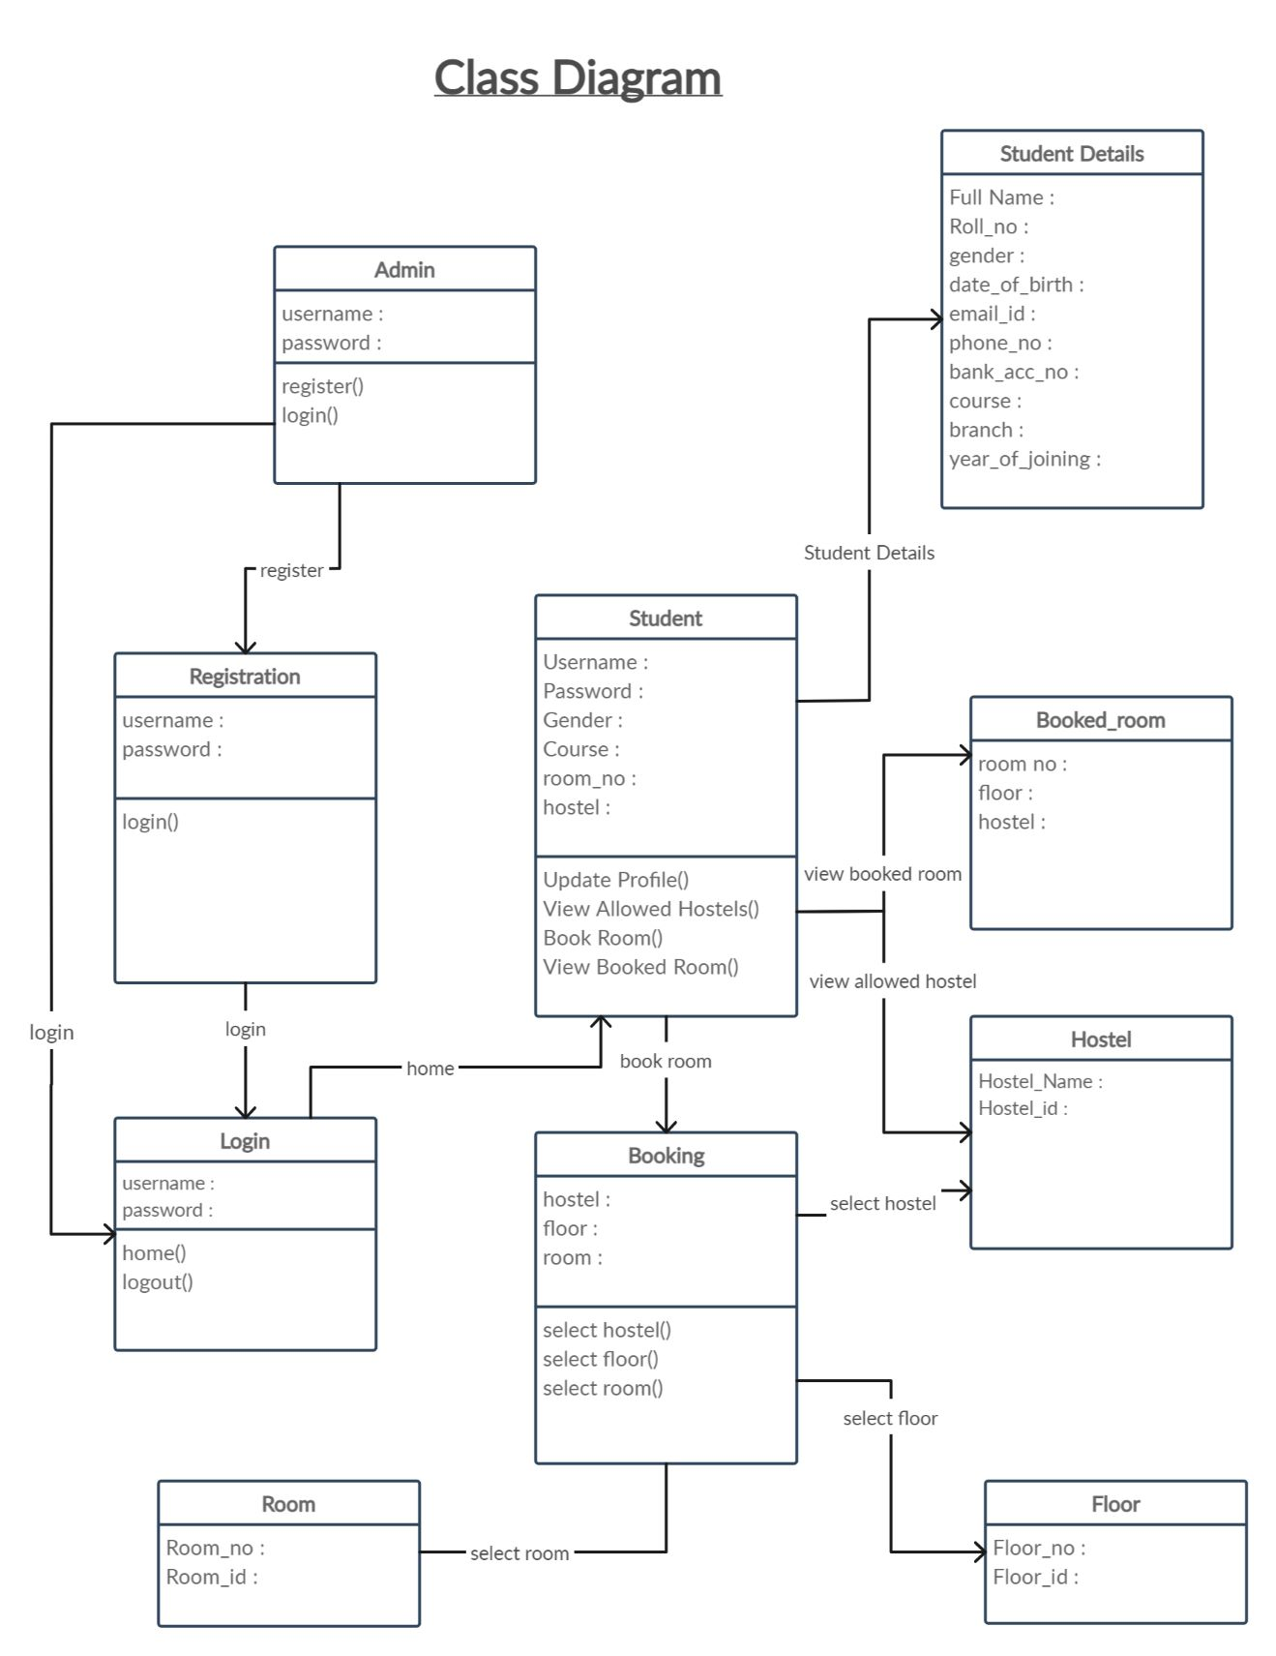



**CHAPTER-6**

**SOFTWARE DESIGN**

**6.1 SCHEMA DIAGRAM**

A database schema is the skeleton structure that represents the logical view of the entire database .It define show the data is organized and how the relations among the mare associated. It formulates all the constraints that are to be applied on the data.

A database schema defines its entities and the relationship among them. It contains a descriptive detail of the database, which can be depicted by means of schema diagrams. It’s the database designers who design the schema to help programmers understand the database and make it useful.

**6.2 ER DIAGRAM**

An Entity Relationship (ER) Diagram is a type of flowchart that illustrates how “entities” such as people, objects or concepts relate to each other within a system. ER Diagrams are most often used to design or debug relational databases in the fields of software engineering, business information systems, education and research. Also known as ERDs or ER Models, they use a defined set of symbols such as rectangles, diamonds, ovals and connecting lines to depict the interconnectedness of entities, relationships and their attributes. They mirror grammatical structure, with entities as nouns and relationships as verbs.

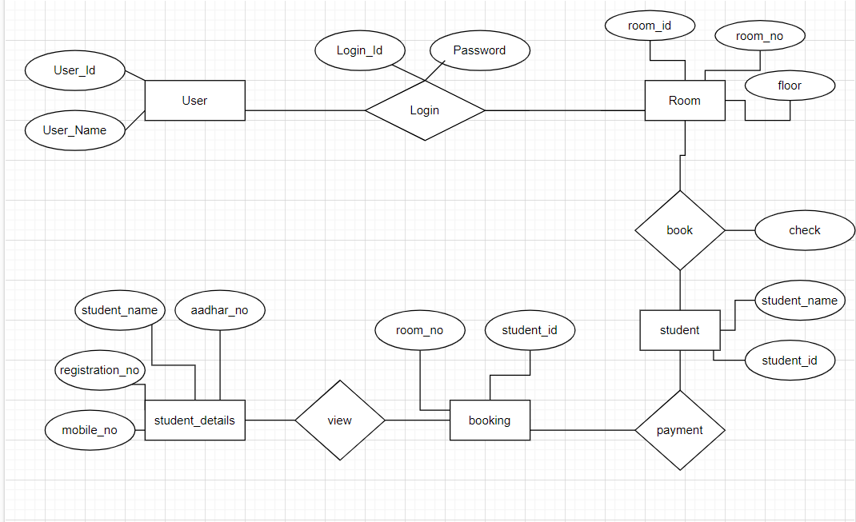



**CHAPTER-7**

**INTERFACE SCREENSHOT**

**7.1 OUTPUT SCREEN OF HOSTEL RESERVATION**

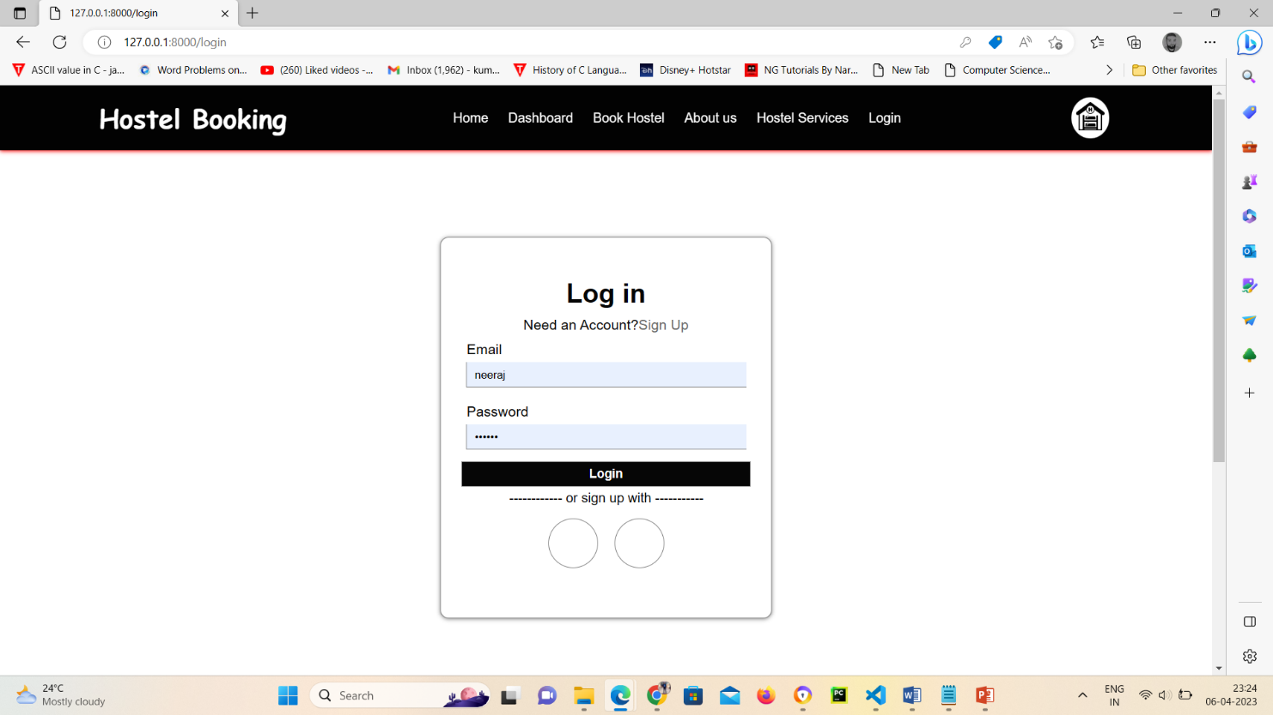

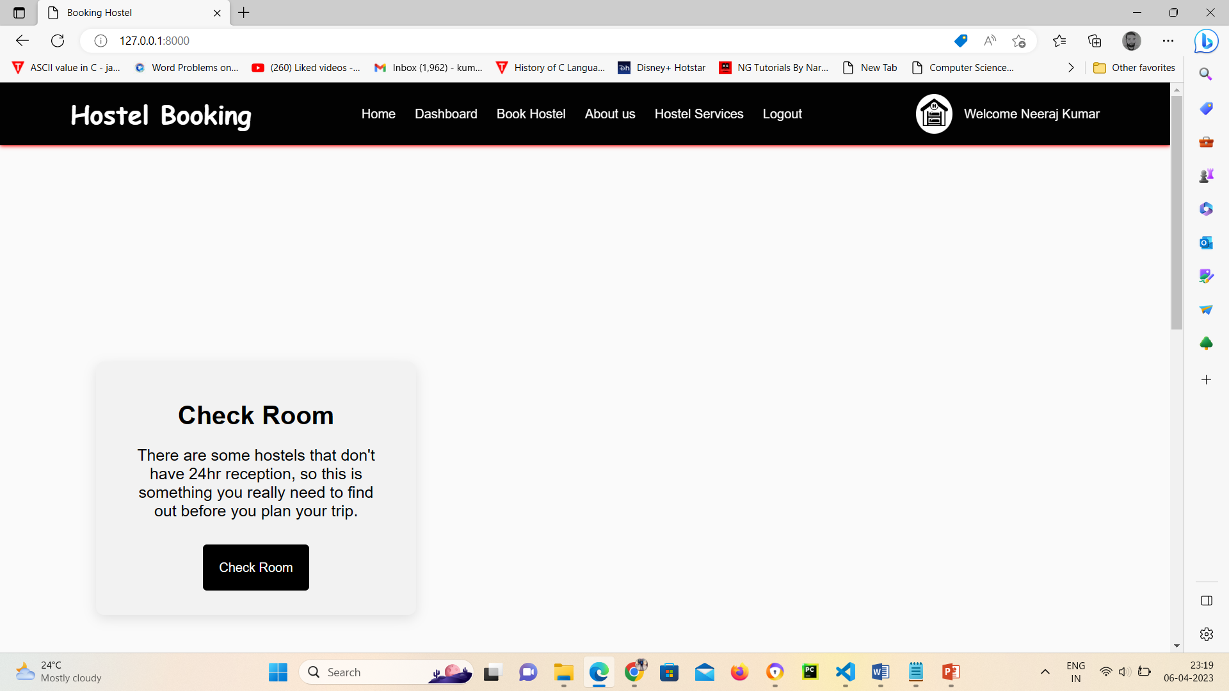

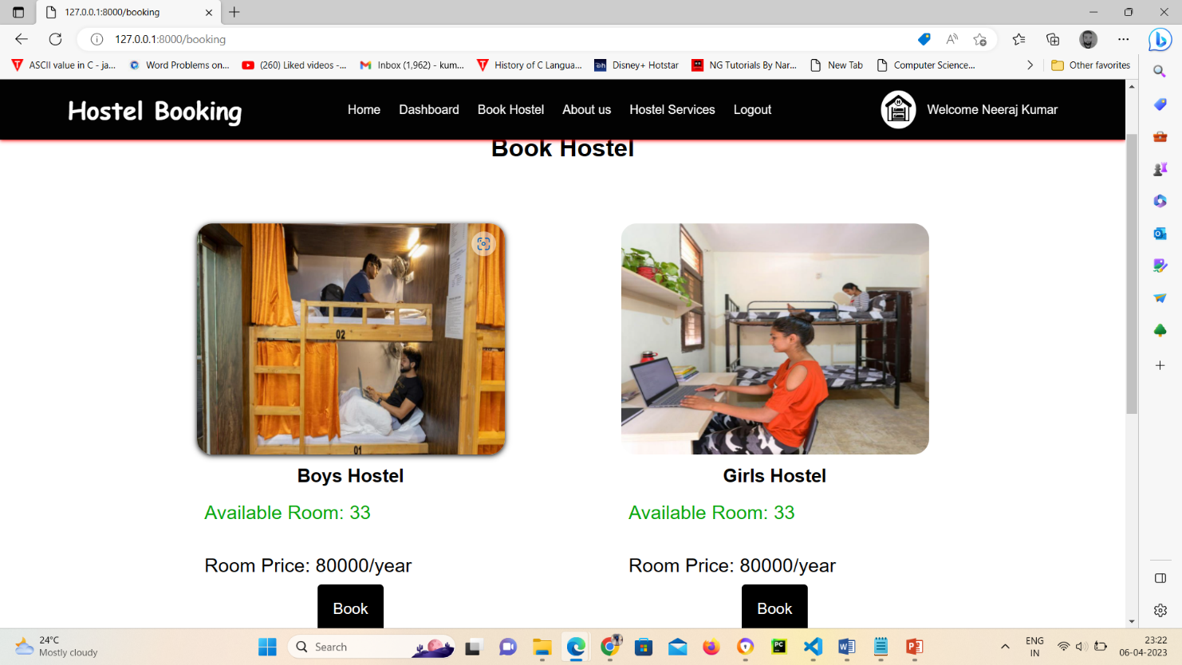

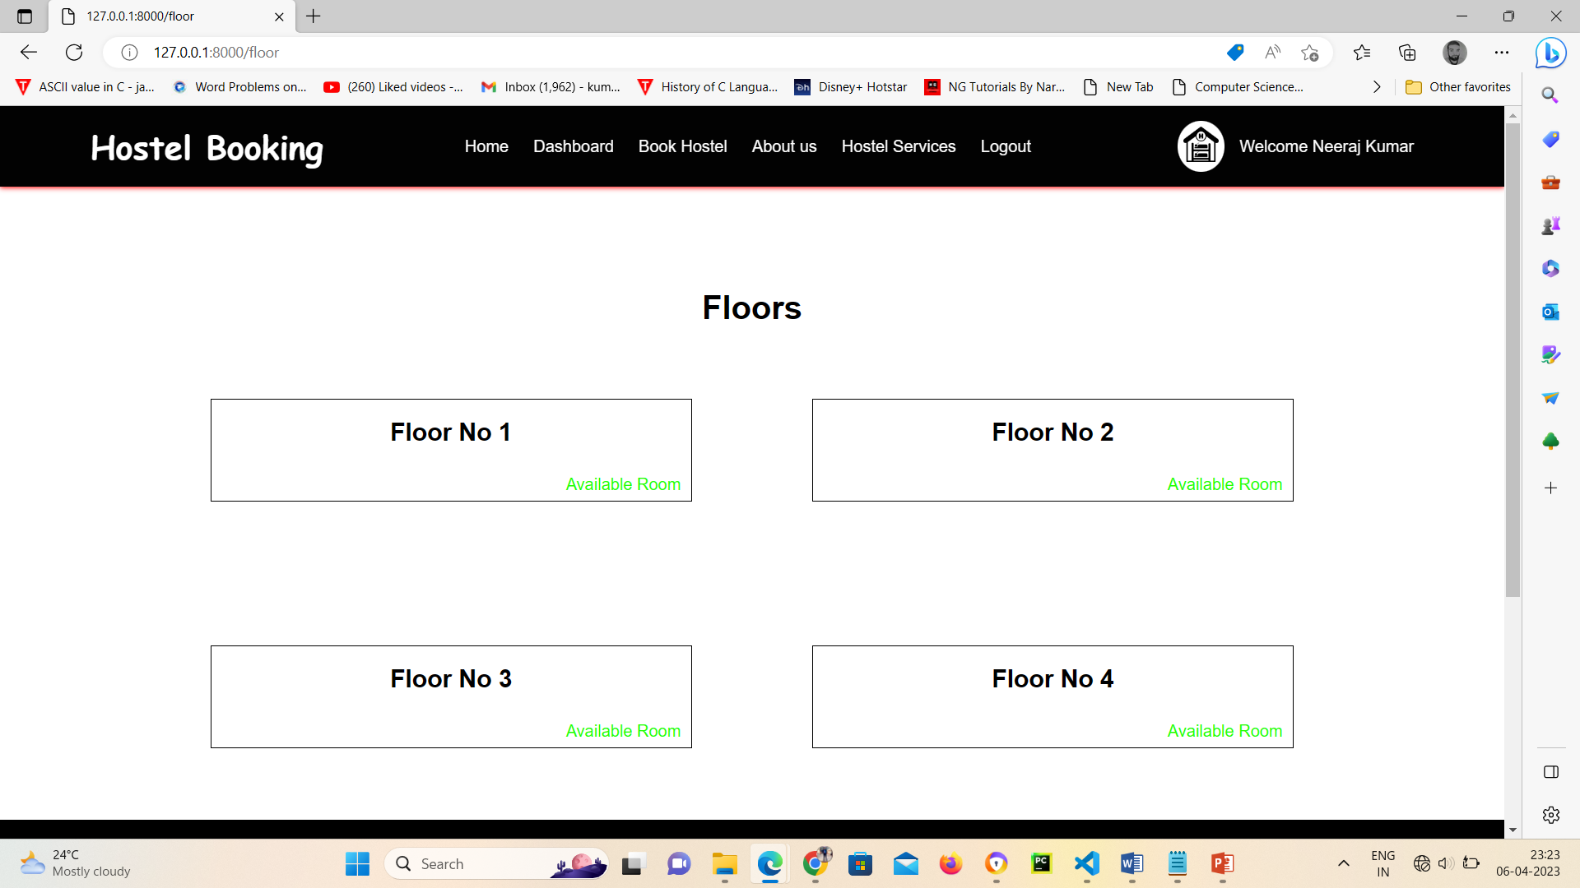

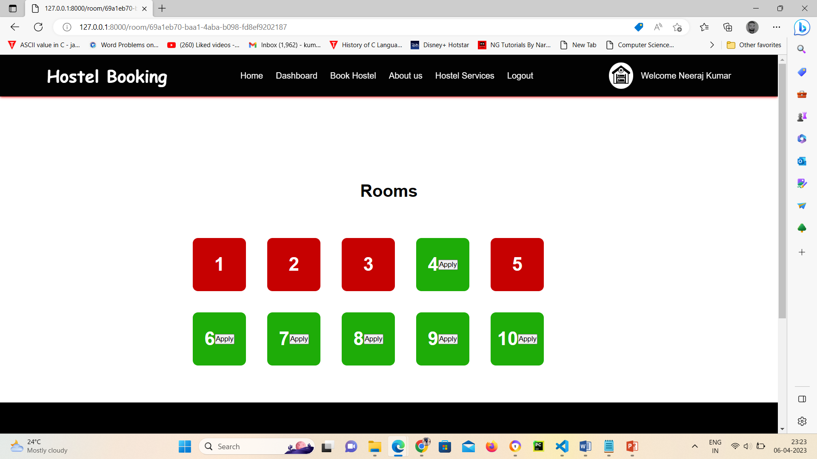

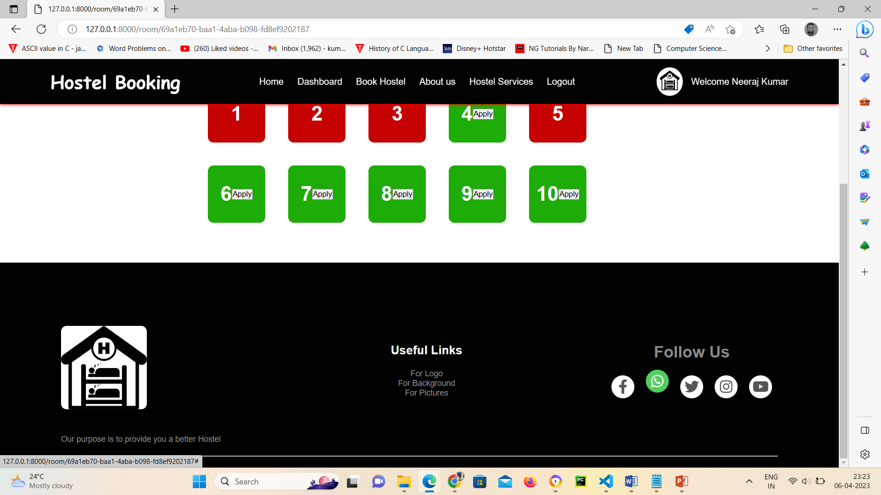

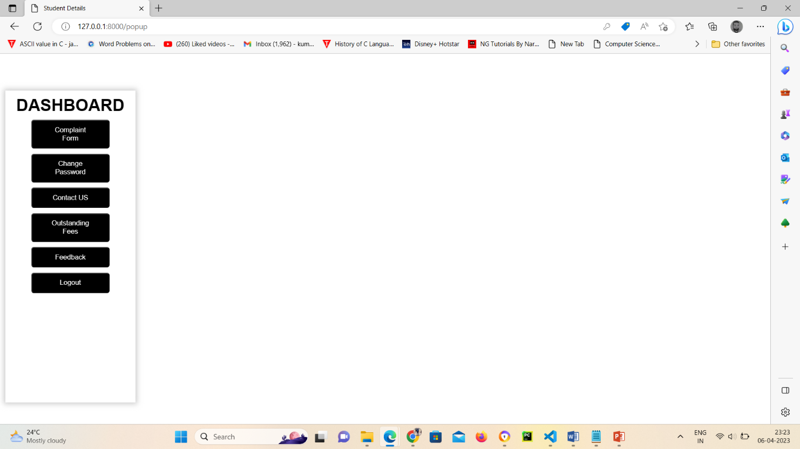

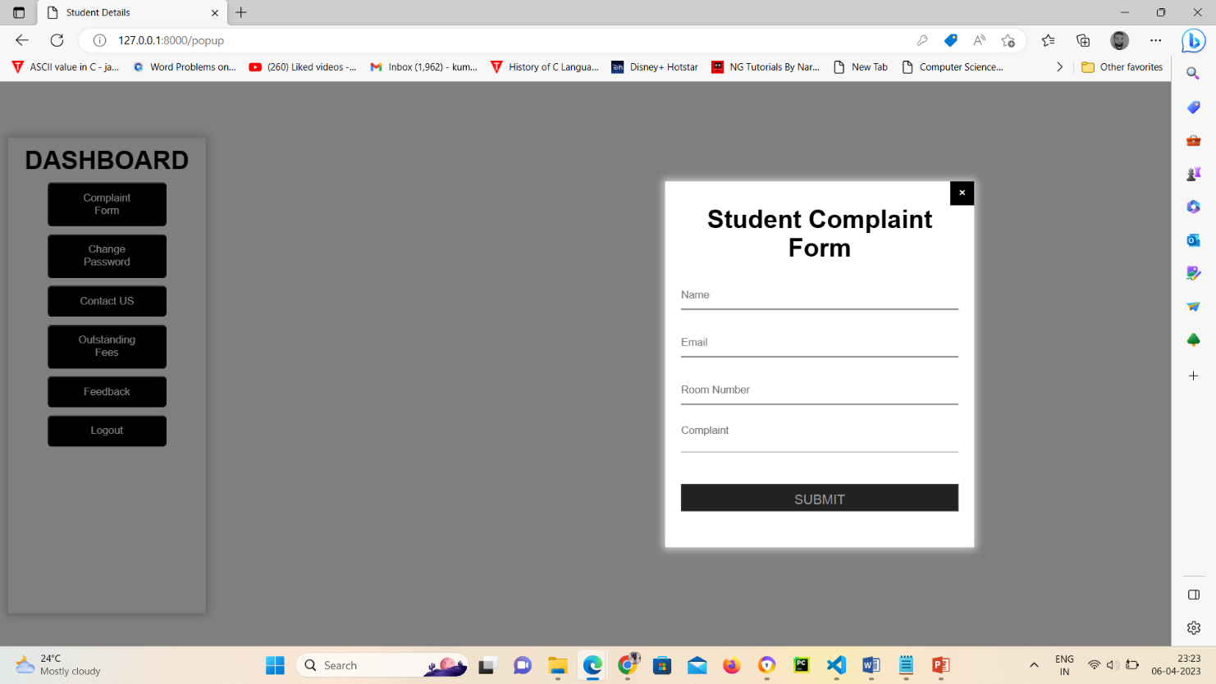

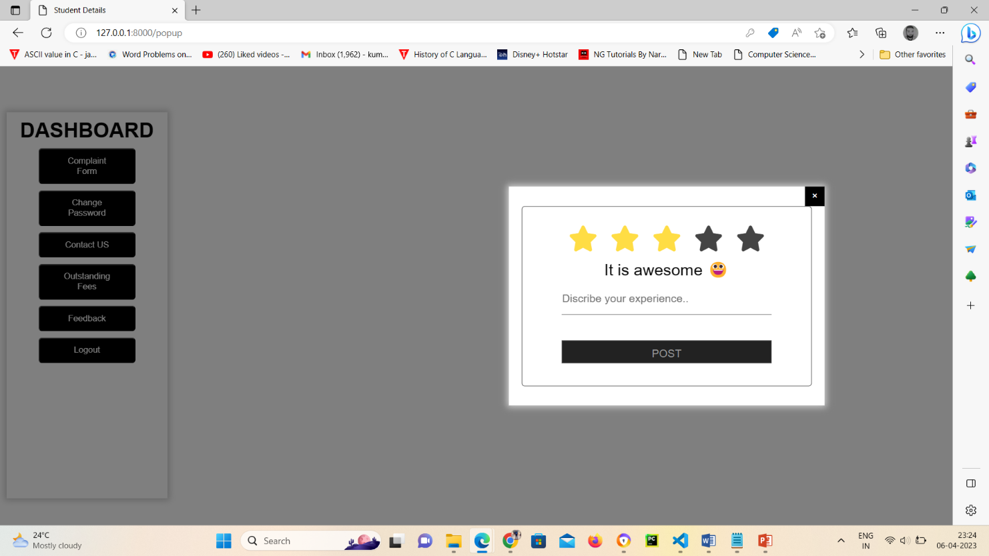

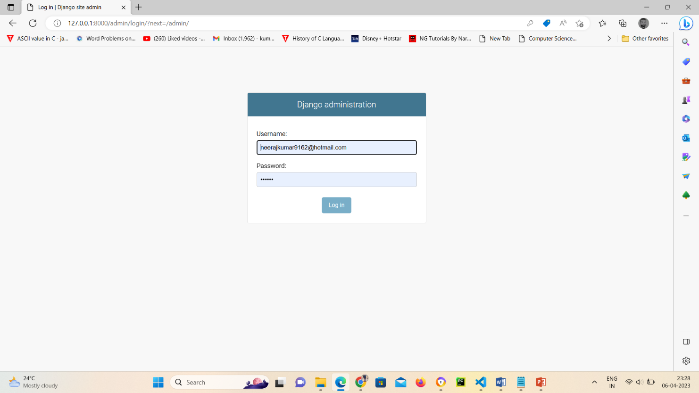

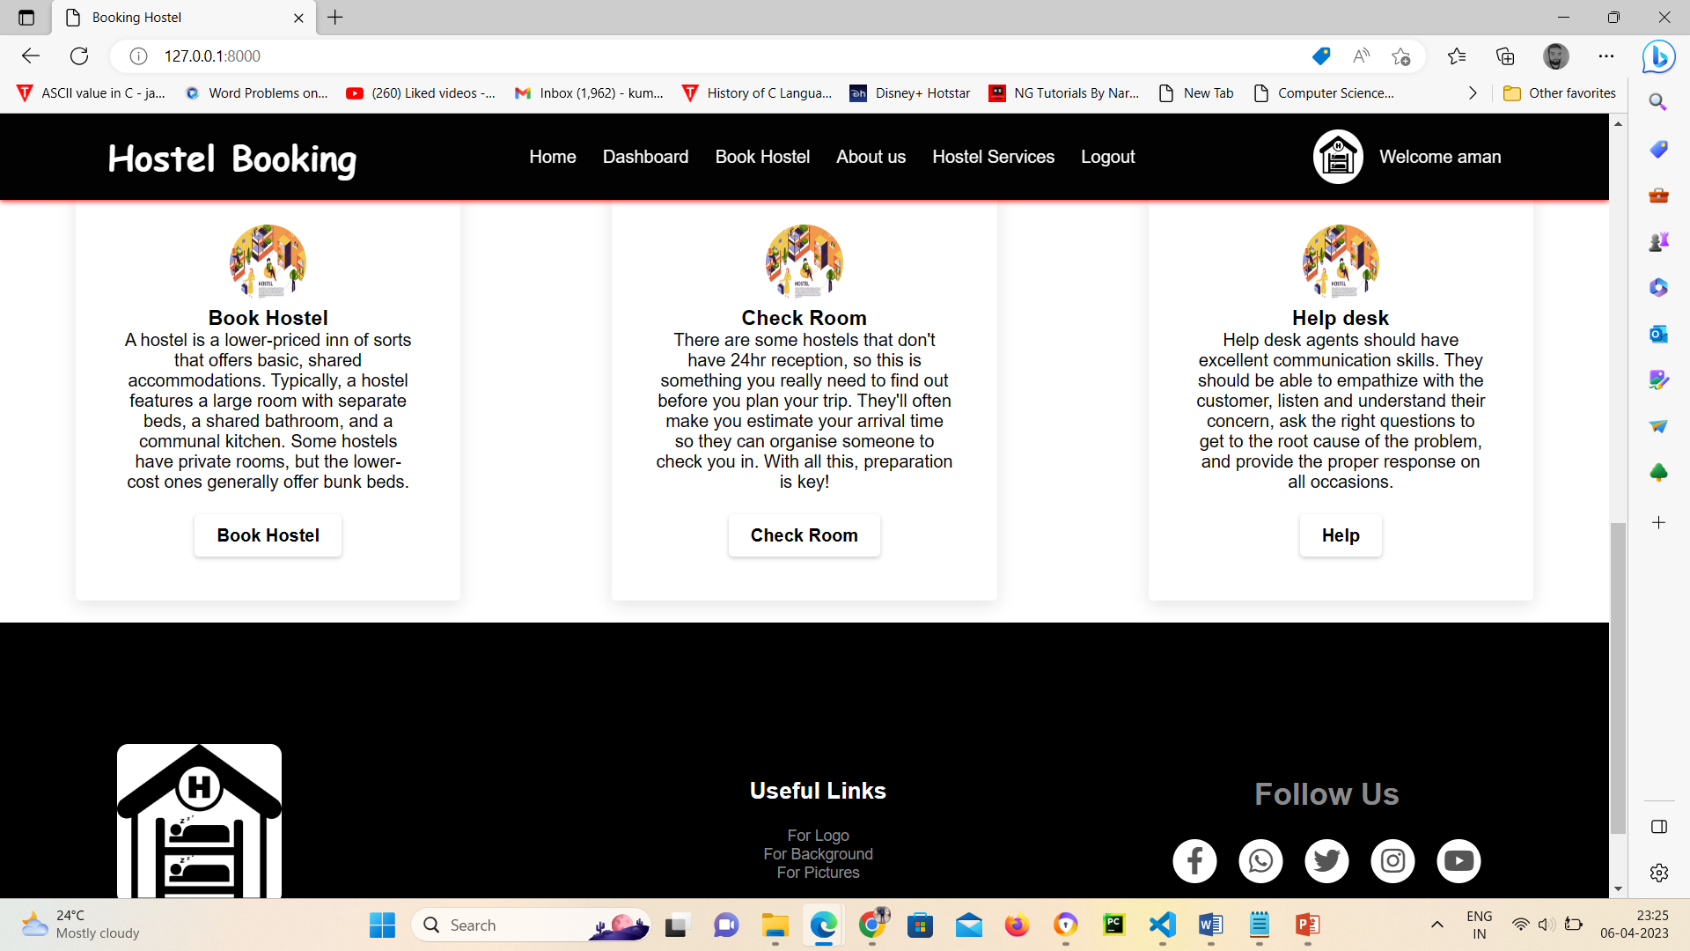



**CHAPTER-8**

**DEPLOYMENT**

**8.1 INTRODUCTION**

This chapter describes how to deploye the project on a fresh machine. It includes Installation steps & snapshots of pre-required software’s like Github. Installation steps & snapshots of the application developed under the major project. VS Code is the official Integrated Development Environment (IDE) for E-Commerce Website, based on eclipse IDEA. On top of Eclipse powerful code editor and developer tools, Github offers even more features that enhance your productivity when building Website.

**8.2 DOWNLOADVS CODE**

You will need to install vs code on your Windows computer. Vs code is an edit or for developing a website application.Download vs code for free from developer Microsoft .

Make sure to download the correct version for your version of Windows. To determine if you are running a3 2-bit or 64-bit installation.

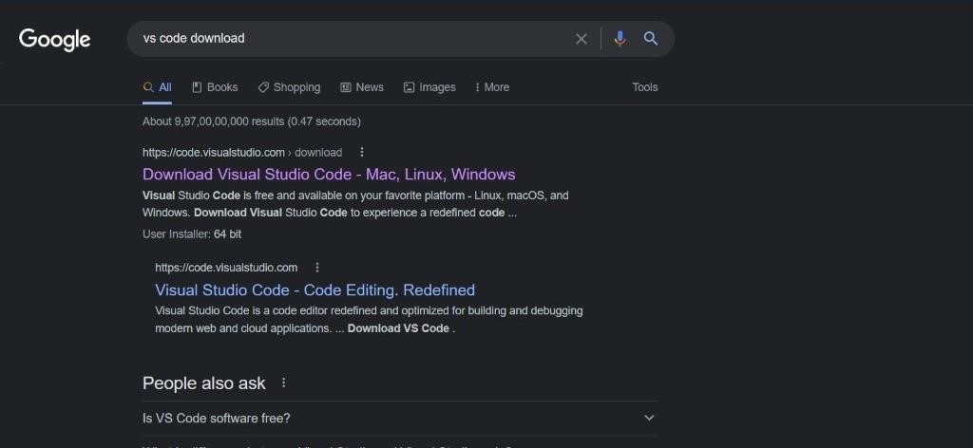

Download

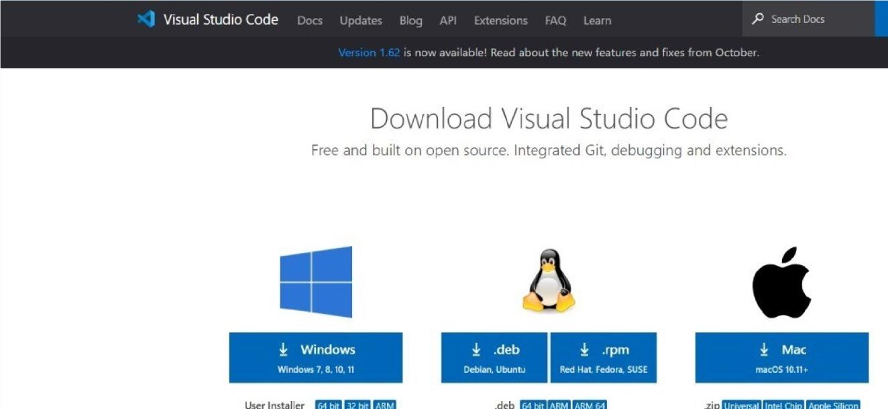

Download

Shows the page where we can download the software.

**8.3 RUN THE SETUP PROGRAM AND FOLLOW THE PROMPTS**

Most users can leave every thing at the default settings, though you can change the installation location if you want to install vs code on a different drive.

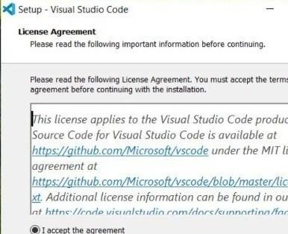

Install

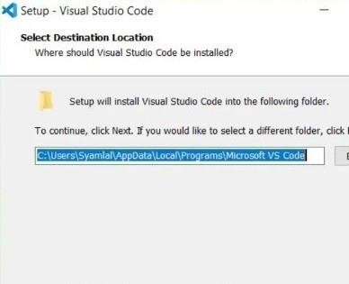

Select Destination Location Vs-code ide install in c drive

Shows the page where user need to click next.



Install

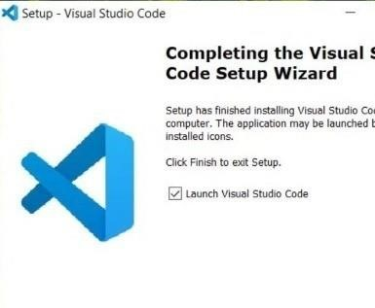

shows that Installation of vs code is finished.

After the successful installation vs code, now we will deploy the app. Vs code sets up new projects to deploy to the vs code or a connected device with just a few clicks. Once your app is installed, Instant Run allows you to push code changes without building a new APK.

To build and run your website, select Run in the menu bar (or click Run in the toolbar). Ifit's the first time running the app, vs code asks you to select a deployment target as shown in figure. Select adevice to install and run your website.

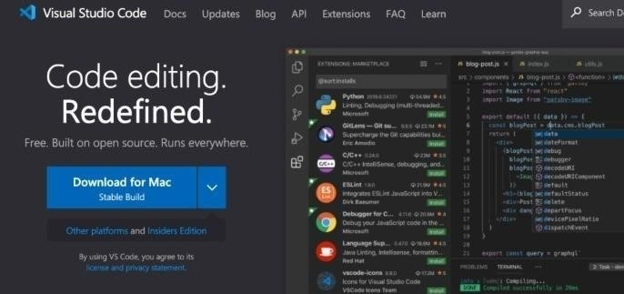

Finally Install VS Code

shows the prompt which appear on the screen in android studio while running the application. In this prompt user needs to select the device to deploy the application.

If the dialog says, "No USB devices or running emulators detected," then you need to upend or launch an emulator by clicking a device listed under Available Virtual Devices. If there are no virtual devices listed, click Create New Virtual Device and follow the Virtual Device Configuration wizard (see Create and Manage Virtual Devices).

**8.4 CHANGE THE RUN/DEBUG CONFIGURATION**

When your un your website for the first time ,vs code use side fault run configuration. The run configuration specifies the module to run ,package to deploy, activity to start, target device, emulator settings, locate options, and more.

The default run/debug configuration launches the default project activity and uses the Select Deployment Target dialog for target device selection. If the default settings don't suit your project or module, you can customize the run/debug configuration, or even create a new one ,at the project ,default, and module levels. To edit a run/debug configuration, select Run Edit Configuration

**8.5 CHANGE THE BUILD VARIANT**

By default, VS CODE builds the debug version of your website, which is intended only for use during development, when you click Run.

To change the build variant vs code uses, select Build Select Build Variant in the menu bar (or click .

Build Variants in the tool windows bar),and then select a build variant from the drop-down menu. By default, new projects are setup with two build variants: a debug and release variant. You need to build there lease variant to prepare your app for public release.

To build other variations of your app, each with different features or device requirements, you can define additional build variants.

**8.6 INSTALLATION OF SQLITE**

SQLite is famous for its great feature zero-configuration, which means no complex setup or administration is needed. This chapter will take you through the process of setting up SQLite on Windows, Linux and Mac OS X.

## **Install SQLite on Windows**

* **Step 1** − Go to [SQLite download page](https://www.sqlite.org/download.html), and download precompiled binaries from Windows section.
* **Step 2** − Download sqlite-shell-win32-*.zip and sqlite-dll-win32-*.zip zipped files.
* **Step 3** − Create a folder C:\>sqlite and unzip above two zipped files in this folder, which will give you sqlite3.def, sqlite3.dll and sqlite3.exe files.
* **Step 4** − Add C:\>sqlite in your PATH environment variable and finally go to the command prompt and issue sqlite3 command, which should display the following result.

C:\>sqlite3

SQLite version 3.7.15.2 2013-01-09 11:53:05

Enter ".help" for instructions

Enter SQL statements terminated with a ";"

sqlite>

## **Download SQLite tools**

To download SQLite, you open the [download page](https://www.sqlite.org/download.html) of the SQlite official website.

1. First, go to the [https://www.sqlite.org](https://www.sqlite.org/) website.
2. Second, open the download page <https://www.sqlite.org/download.html>

SQLite provides various tools for working across platforms e.g., Windows, Linux, and Mac. You need to select an appropriate version to download.

For example, to work with SQLite on Windows, you download the command-line shell program as shown in the screenshot below.

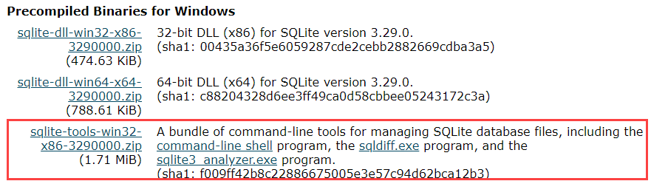

The downloaded file is in the ZIP format and its size is quite small.

## **Run SQLite tools**

Installing SQLite is simple and straightforward.

1. First, create a new folder e.g., C:\sqlite.
2. Second, extract the content of the file that you downloaded in the previous section to the C:\sqlite folder. You should see three programs in the C:\sqlite folder as shown below:

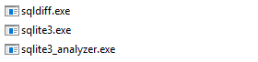

First, open the command line window:

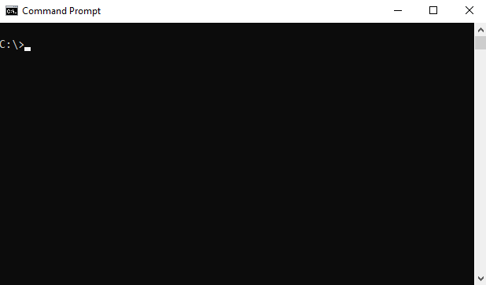

and navigate to the C:\sqlite folder.

C:\cd c:\sqlite

C:\sqlite>

Second, type sqlite3 and press enter, you should see the following output:

C:\sqlite>sqlite3

SQLite version 3.29.0 2019-07-10 17:32:03

Enter ".help" for usage hints.

Connected to a transient in-memory database.

Use ".open FILENAME" to reopen on a persistent database.

sqlite>Code language: CSS (css)

Third, you can type the .help command from the sqlite> prompt to see all available commands in sqlite3.

sqlite> .help

.archive ... Manage SQL archives: ".archive --help" for details

.auth ON|OFF Show authorizer callbacks

.backup ?DB? FILE Backup DB (default "main") to FILE

.bail on|off Stop after hitting an error. Default OFF

.binary on|off Turn binary output on or off. Default OFF

.cd DIRECTORY Change the working directory to DIRECTORY

...Code language: PHP (php)

Fourth, to quit the sqlite>, you use  .quit command as follows:

sqlite> .quit

c:\sqlite>Code language: CSS (css)

## **Install SQLite GUI tool**

The sqlite3 shell is excellent…However, sometimes, you may want to work with the SQLite databases using an intuitive GUI tool.

There are many GUI tools for managing SQLite databases available ranging from freeware to commercial licenses.

### **SQLiteStudio**

The SQLiteStudio tool is a free GUI tool for managing SQLite databases. It is free, portable, intuitive, and cross-platform. SQLite tool also provides some of the most important features to work with SQLite databases such as importing, exporting data in various formats including CSV, XML, and JSON.

You can download the SQLiteStudio installer or its portable version by visiting the [download page](https://github.com/pawelsalawa/sqlitestudio/releases).  Then, you can extract (or install) the download file to a folder e.g., C:\sqlite\gui\ and launch it.

The following picture illustrates how to launch the SQLiteStudio:



**CHAPTER-9**

**CONCLUSION AND FUTURE WORK**

**9.1 CONCLUSION**

The conclusion of a hostel reservation system would depend on the specific goals and objectives of the system. In general, a hostel reservation system should aim to provide a convenient and efficient way for customers to book accommodations, while also helping the hostel manage their reservations and resources.

**Some potential benefits of a hostel reservation system could include:**

1. **Increased efficiency:** With a reservation system in place, the hostel can automate many of the processes involved in booking and managing reservations. This can save time and reduce the risk of errors or double bookings.
2. **Improved customer experience:** A reservation system can provide customers with a user-friendly interface to browse available rooms, select dates, and make payments. This can help to create a positive impression of the hostel and increase customer satisfaction.
3. **Better resource management:** A reservation system can help the hostel to track occupancy rates and plan for staffing, maintenance, and other resources. This can help to optimize operations and reduce waste.

Overall, a well-designed hostel reservation system can benefit both the hostel and its customers by streamlining the booking process and improving the overall experience.

**9.2 FUTURE WORK**

We currently have cash on delivery payment option on our website, In future we will use online payment gateway method in our website.

Our website is not currently on the server in the future we will host our website.

Website by purchasing a domain through server.

**References**

1. W3School: <https://www.w3schools.in/>
2. GeeksforGeeks: [www.geeksforgeeks.org/computer-science-projects/](http://www.geeksforgeeks.org/computer-science-projects/)
3. Youtube : <https://www.youtube.com/results?search_query=project+for+website+development>
4. <https://www.sqlite.org>

**APPENDIX:- 1**

**GLOSSARY OF TERMS**

|  |  |
| --- | --- |
| A |  |
| Application | From a component perspective, an Android application consists of one or more activities, services, listeners, and intent receivers. From a source file perspective, an Android application consists of code, resources, assets, and a single manifest. During compilation, these files are packaged in a single file called an application package file (.apk). |
| C |  |
| CSS | CSS stands for Cascading Style Sheets.CSS describes how HTML elements are to be displayed on screen, paper, or in other media.CSS saves a lot of work. It can control the layout of multiple web pages all at once.External stylesheets are stored in CSS files. for example, to alter the font, color, size, and spacing of your content, split it into multiple columns, or add animations and other decorative features. |
| D |  |
| DJANGO | Django is a high-level Python web framework that enables rapid development of secure and maintainable websites. Built by experienced developers, Django takes care of much of the hassle of web development, so you can focus on writing your app without needing to reinvent the wheel. |
| H |  |
| HTML | Extensible Mark up Language (XML) is a mark up language that defines a set of rules for encoding document in a format that is both human Readable and machine-readable. |
| **S** |  |
| SQLite | SQLite is an in-process library that implements a [self-contained](https://sqlite.org/selfcontained.html), [serverless](https://sqlite.org/serverless.html), [zero-configuration](https://sqlite.org/zeroconf.html), [transactional](https://sqlite.org/transactional.html) SQL database engine. The code for SQLite is in the [public domain](https://sqlite.org/copyright.html) and is thus free for use for any purpose, commercial or private. SQLite is the [most widely deployed](https://sqlite.org/mostdeployed.html) database in the world with more applications than we can count, including several [high-profile projects.](https://sqlite.org/famous.html) |

**Project Summary**

***About Project***

|  |  |
| --- | --- |
| **Title of the project** | DESIGN & DEVELOPMENT OF  HOSTEL RESERVATION SYSTEM |
| **Semester** | 6th |
| **Members** | 04 |
| **Team Leader** | NEERAJ KUMAR |
| **Describe role of every member in the project** | **Neeraj Kumar :-** Planning ,Designing, Database, Front-End  and  Documentation.  **Mohit Gautam :-** Requirement Gathering and Backend.  **Kapil Barsker :-**Testing and Deployment.  **Md Rehan:-** Django, ppt. |
| **What is the motivation for selecting this project?** | There can be several motivations for selecting a Hostel Reservation System project, some of which are:  1. Practicality:  2. Learning opportunity:  3. Innovation:  4. Entrepreneurship: |
| **Project Type**  **(Desktop Application, Web**  **Application, Mobile App, Web)** | Web Application |

***Tools &Technologies***

|  |  |
| --- | --- |
| **Programming language**  **used** | PYTHON |
| **IDE used**  **(With version)** | VS Code (Version 5.0.2) |
| **Version control system**  **(with version)** | 3.10.8 |
| **Front End Technologies (With version, wherever Applicable)** | HTML, CSS, JAVASCRIPT and BOOTSTRAP |
| **Back End Technologies (With version, wherever applicable)** | Django (Version 4.1.1) |
| **Database used**  **(With version)** | SQLite (**Version** 3.41.2) |

***Software Design & Coding***

|  |  |  |  |
| --- | --- | --- | --- |
| **Is prototype of the software developed?** | | Yes | |
| **SDLC model followed (Waterfall, Agile, Spiral etc.)** | | Prototype Model | |
| **Why above SDLC model is followed?** | | Because Software is deployed more quickly and improved more regularly. | |
| **Justify that the SDLC model mentioned above is followed in the project.** | | Web Application is deployed more quickly and improved more regularly. | |
| **Software Design approach followed**  **(Functional or Object Oriented)** | | Object oriented Approach | |
| **Name the diagrams developed**  **(According to the Design approach followed)** | | - | |
| **In case Object Oriented approach is followed, which of the OOPS principles are covered in design?** | | Encapsulation Inheritance | |
| **No. of Tiers**  **(Example 3-tier)** | | - | |
| **Total no. of front-end pages** | | - | |
| **Total no. of tables in database** | | - | |
| **Database is in which Normal Form?** | | - | |
| **Are the entries in database encrypted?** | | - | |
| **Front end validations applied (Yes / No)** | Yes | |
| **Session management done**  **(In case of web applications)** | No | |
| **Is application browser compatible**  **(In case of web applications)** | No | |
| **Exception handling done**  **(Yes / No)** | Yes | |
| **Commenting done in code**  **(Yes / No)** | Yes | |
| **Naming convention followed**  **(Yes / No)** | Yes | |
| **What difficulties faced during deployment of project?** | - | |
| **Total no. of Use-cases** | 2 | |
| **Give titles of Use-cases** | 1. Admin 2. Student | |

***Project Requirements***

|  |  |
| --- | --- |
| **MVC architecture followed**  **(Yes / No)** | Yes |
| **If yes, write the name of MVC architecture followed (MVC-1, MVC-2)** | MVC-1 |
| **Design Pattern used**  **(Yes / No)** | No |
| **If yes, write the name of Design Pattern used** | - |
| **Interface type**  **(CLI / GUI)** | GUI |
| **No. of Actors** | 2 |
| **Name of Actors** | Admin and Student |
| **Total no. of Functional**  **Requirements** | 4 |
| **List few important non- Functional Requirements** | Performance User Friendly Security & Safety  Availability  Reliability |

***Testing***

|  |  |
| --- | --- |
| **Which testing is performed?**  **(Manual or Automation)** | Manual |
| **Is Beta testing done for this project?** | No |

|  |  |
| --- | --- |
|  |  |
|  |  |

***Write project narrative covering above mentioned points***

|  |
| --- |
| The hostel reservation system project aims to simplify the process of reserving hostel rooms for students and travelers. The system will be a web-based application that allows users to search for available rooms, make reservations, and manage their bookings. The system will provide a user-friendly interface that enables users to book a room with ease. The following is a project narrative that covers the major points of the hostel reservation system.  User Registration:  Room Search:  Booking Management:  Payment  Booking Cancellation and Modification:  Admin Dashboard:  Conclusion: |

NEERAJ KUMAR 0187CS201106

MOHIT GAUTAM 0187CS201095 Guide Signature

MD REHAN 0187CS201087 Prof. Amit Kumar Rathore

KAPIL BARSKER 0187CS201073